**Day 1 Lab Assignments**

1. Design the home page that you made in (client side technologies) course using HTML5 structural elements, similar to this layout:

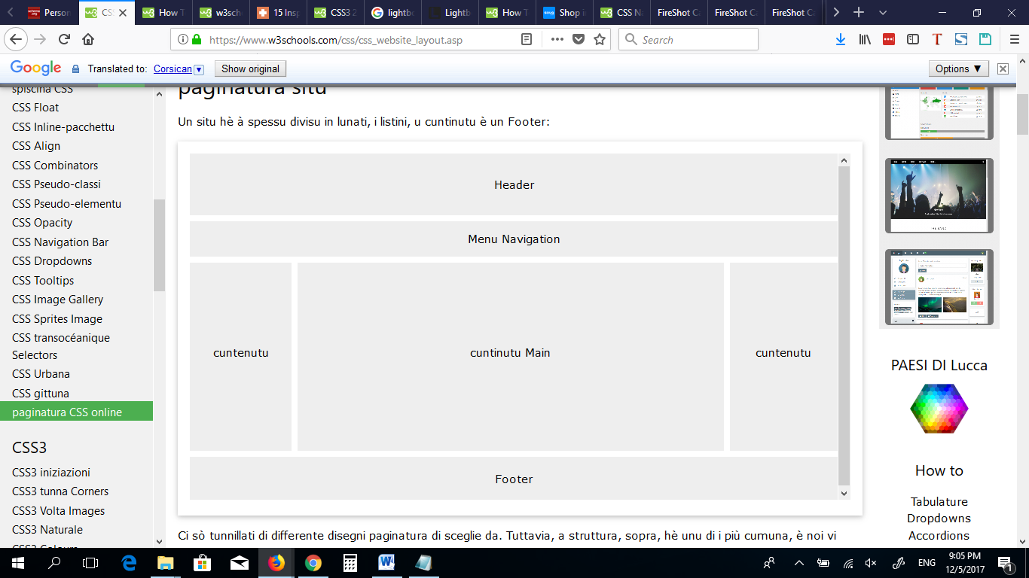

1. Make registration form and try new form elements and attributes on it.
2. Make simple CV with skill bars indicating your skills , as the following (Just make the main items and layout, and you can complete the other details on it later)

**(use new HTML5 structural elements in layout):**

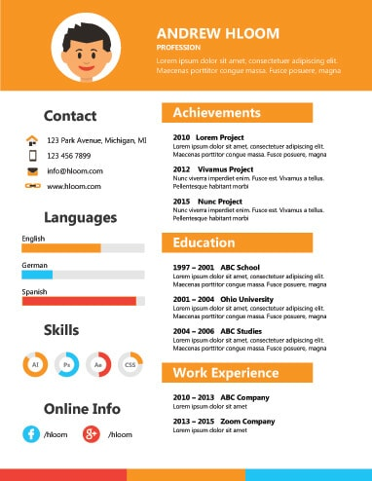

* 1. Use Time tag to display your birthdate in your CV.
  2. Use meter for skills section, and making it as circles is **Bonus**.

1. In assignment No.3, Use hidden audio element (without controls), that plays ringing sound when mouse is over contact section, and stop it when the mouse is away (You can search for a sound here: <https://www.soundsnap.com/search/audio> ).
2. In Assignment No.3, use video element to display a video about you in your page.
3. Use HTML5 drag and drop, to make the following assignment:

Make a div with width and height: 100px, and make a border and background color for it, and make an image that can be dragged and dropped on the div.

* 1. Make 3 images, and make the div allowing drop of specific image only.
  2. Make the image back to its original position if dragged to any place rather than the div (**Bonus**).
  3. Change the div background when the image is dropped over the div
  4. Use session storage to store the score, so the score isn’t changed if the user refreshed the page

1. Make a page that has a button that when clicked gets your location, and show it on google maps on a new window (Use HTML5 GeoLocation ).

**<Thank>YOU </Thank>**